

Graduation project

**“A&M Shop App”**

Team Work

#### Ahmed Mustafa Ahmed Atef Wagdy Sayed Mohamed Yasser

Supervised

**Eng / Marwa Talat**

### Acknowledgment:

We give thanks to Allah, the Almighty, for His countless blessings and for guiding our efforts to a successful conclusion. The completion and success of this project would not have been possible without the support and guidance of many individuals, and we feel fortunate to have received this assistance throughout the journey.

We would like to express our deepest gratitude to our respected mentors, Eng. Marwa Talat and Next Academy, for their invaluable guidance and advice at key moments, and for steering us in the right direction. Their support has been instrumental in the achievement of this project.

### Abstract:

The **A&M shop Mobile App** is a comprehensive solution designed to enhance the online shopping experience for users. Built using the **Flutter framework**, the app allows users to shop for a wide variety of products easily and efficiently. Key features include an intuitive search bar for fast product searches, the ability to add products to a favorites list, a seamless shopping cart experience, and secure payment integration via Visa.

The app is designed with a user-friendly interface, offering functionalities such as profile management, dark mode for reduced eye strain, and a personalized user experience. A backend system manages user and product data, ensuring efficient resource handling and smooth navigation on both iOS and Android platforms.

Contents

Chapter 1: Introduction 4

* 1. Proposed System Description 5
  2. Problem Definition 5
  3. Objectives 5
  4. General Rules 5

Chapter 2: Functional and Nonfunctional Requirements…………………………………………………………………….8

2.1 Functional Requirement………………………………………………………………………………………………………9

2.2 Non Functional Requirement……………………………………………………………………………………………..11

Chapter 3: System Analysis 13

3.2 Context Diagram 14

Figure 1: Use Case Diagram 14

3.3 Sequence Diagram 17

Chapter 4: System Design 21

4.1 System Design Overview 22

4.2 System Properties 22

4.3 System Tools 23

**Chapter5 : Implementation** 24

5.1 Implementation Overview 25

5.2 Mobile Application Development 26

5.3 The Backend…………………………………………………………………………………………………………………………45

Chapter6 : Conclusion 46

6.1 Conclusion 47

**Chapter7: Future Scope**

**7.1 Future Scope…………………………...…………………………………………………………………………………………….**48

# Chapter 1: Introduction

##### Proposed System Description:

The **A&M shop Mobile App** is designed to offer users a simple and efficient online shopping experience. It is built using the **Flutter** framework, enabling it to run on both iOS and Android platforms. The app allows users to browse various products, add them to their favorites or cart, and complete their purchase securely using Visa

##### Problem Definition:

Many existing e-commerce platforms have inefficient search functionalities and complicated user interfaces, making it difficult for users to find and purchase products quickly. The **A&M** app addresses these issues by providing a fast and intuitive search feature, along with an easy-to-use interface that streamlines the shopping process.

##### Objectives:

The main objectives of The **A&M shop Mobile App** are:

* To create a user-friendly shopping experience.
* To offer fast product searches and a seamless checkout process.
* To enable users to manage their profiles, favorites, and orders efficiently.
* To provide a secure payment method using Visa.

##### 1.4 General Rules:

The general rules for the E-Commerce Application include:

* **Platform Compatibility**: The app must run seamlessly on both **Android** and **iOS** platforms, ensuring consistent functionality and performance across devices. Respectful conduct is required in all interactions within the application.
* **User Authentication :** The app must enforce a secure login system and allow for account management (password change, data updates).

# Chapter 2: Functional and non functional requirments

**Functional Requirements :**

1. **User Registration and Authentication:**

* Users must be able to sign up, log in, and authenticate their accounts.
* Profile management functionalities such as changing the password and updating data.

1. **Product Search and Browsing:**

* Fast and intuitive product search functionality to allow users to search efficiently.
* Browsing through categories and adding products to favorites.

1. **Shopping Cart and Checkout:**

* Users can add products to their shopping cart.
* Seamless checkout process with payment through Visa.

1. **Product Details and Management:**

* Display detailed information for each product.
* Update and manage product listings via a backend system.

1. **Payment Integration:**

* Users must be able to make payments via Visa.

1. **Dark Mode Feature:**

* Support for dark mode for a better user experience in low-light environments.

1. **Contact Us:**

* Users can contact the store via the "Contact Us" page.

1. **Favorites and Order Management:**

* Users can manage favorites and view order history.

**Non-Functional Requirements :**

1. **Cross-Platform Compatibility:**

* The app should work smoothly on both iOS and Android devices.

1. **Performance:**

* Fast performance and smooth navigation.
* Efficient resource management to handle multiple users and products.

1. **Scalability:**

* Ability to scale by adding more products and users.
* Support for future integrations like AI-based recommendations and voice search.

1. **Usability:**

* Easy-to-use interface with a focus on user experience.
* Comfortable dark mode to minimize eye strain during prolonged use.

1. **Security:**

* Secure handling of user data and payment information.

1. **Backend Reliability:**

* Reliable backend for managing user and product data, using APIs like Postman Collections.

1. **Testing and Quality Assurance:**

* The app must undergo unit testing to ensure each component functions as expected.

# Chapter 3: System Analysis

### 3.1 Use Case Diagram

The **Use Case Diagram** illustrates the interactions between the users (actors) and the core functionalities of the **A&M shop App**. It provides a clear view of the primary functions that the system must support to ensure a seamless e-commerce experience for users.

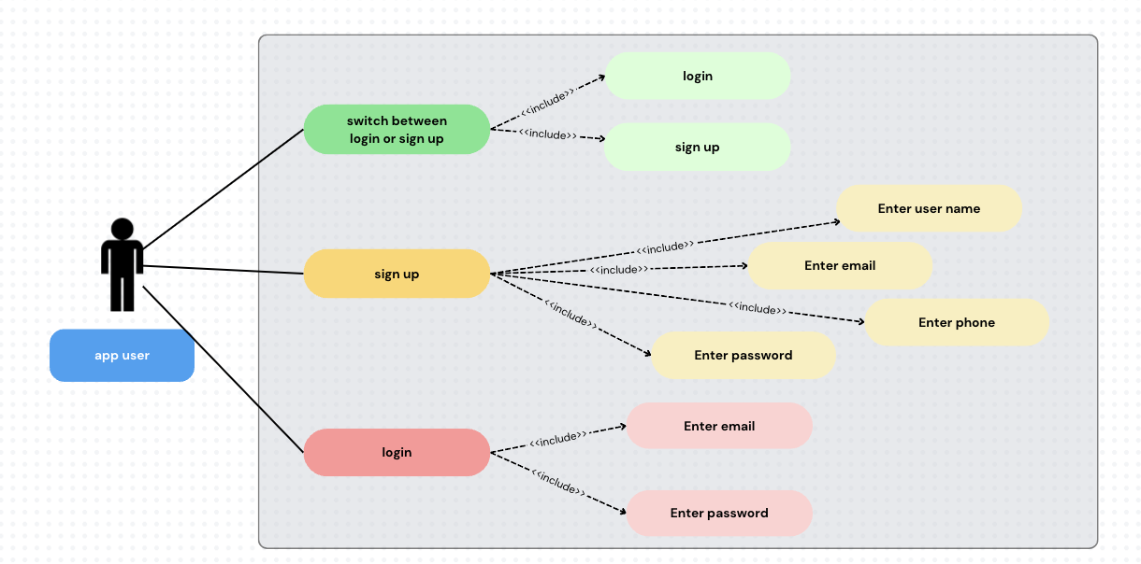

*Figure 1: Use Case Diagram.*

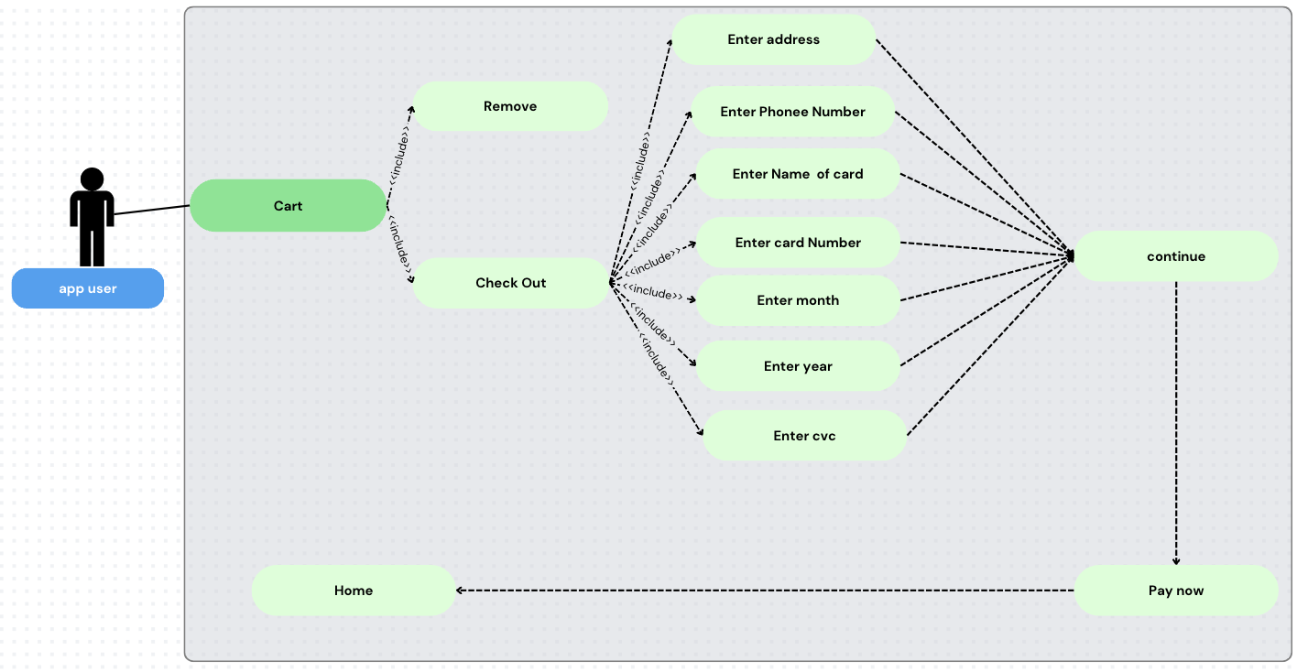

### 3.2Sequence Diagram

A Sequence Diagram shows how objects interact in a particular scenario of the e-commerce system, detailing the order of messages exchanged between them. This diagram helps visualize the flow of control and data during specific use cases.

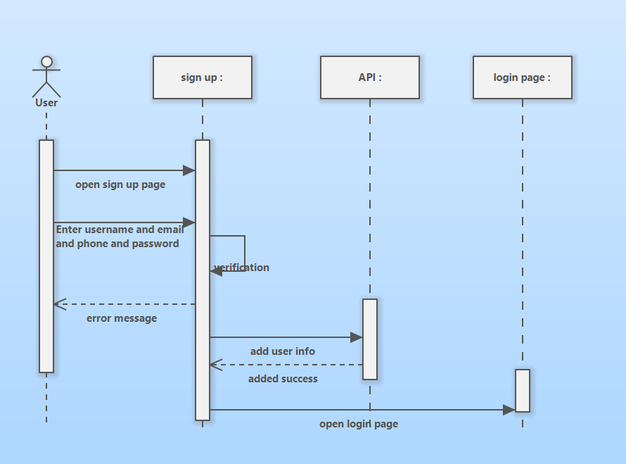

1:Seguance diagram sign up

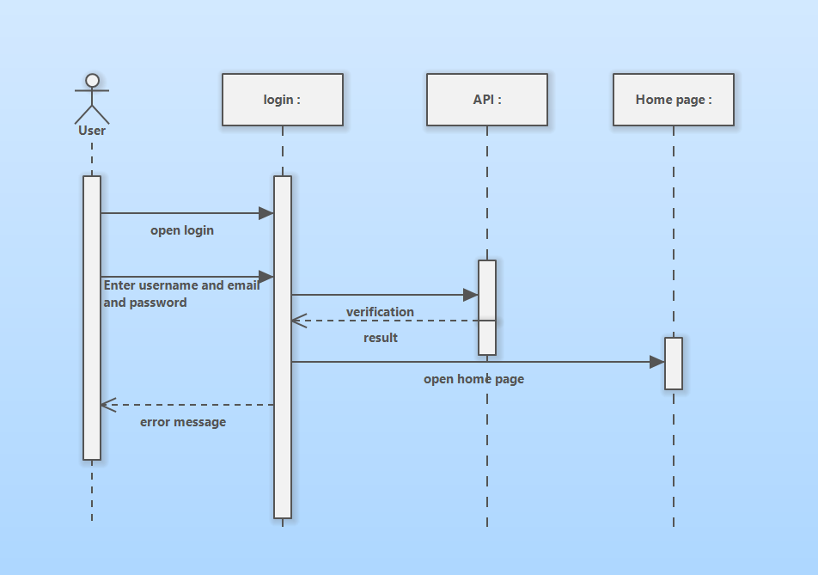

2:Sequance diagram login

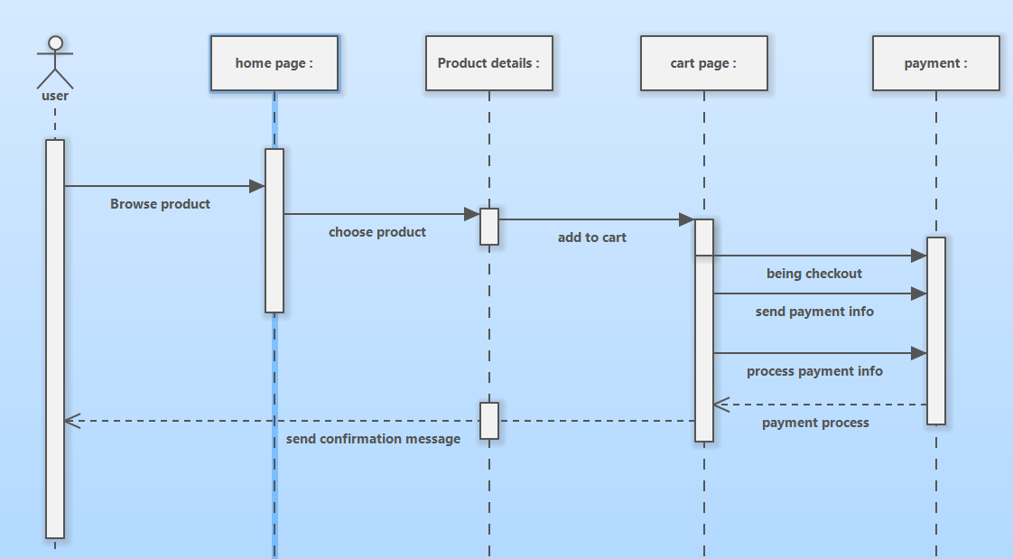

3:Sequance diagram payment

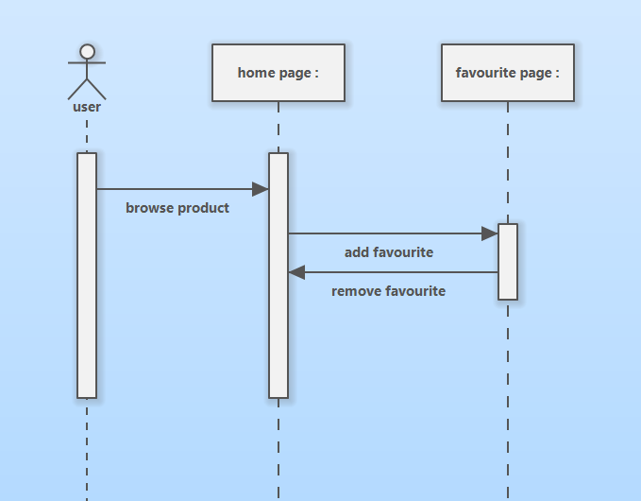

4:Sequance diagram Favorite page

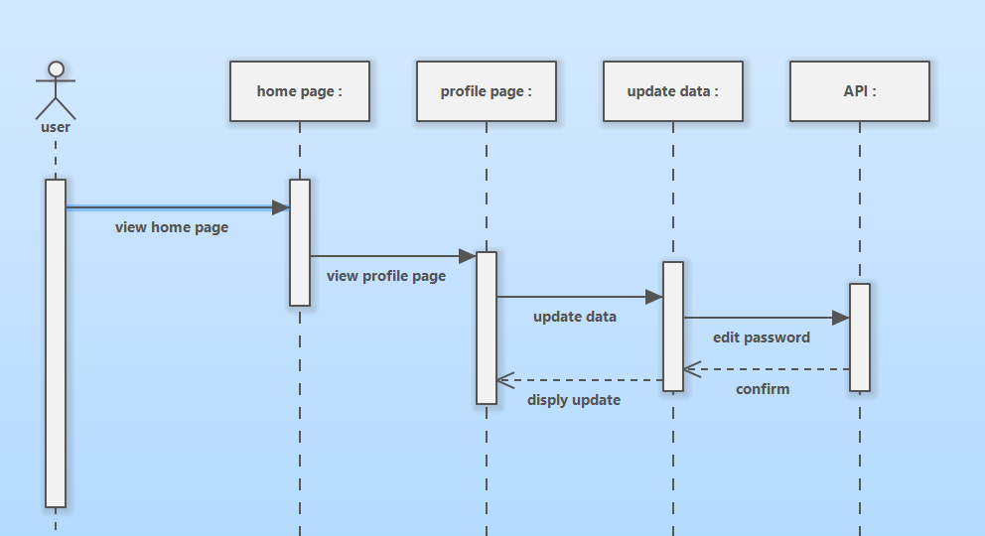

5:Sequance digram update data

# Chapter 4: System Design

### 4.1System Design Overview

The system is designed using the Flutter framework to ensure cross-platform compatibility and high performance. The backend is responsible for managing user and product data, while the frontend provides a smooth and intuitive interface for users.

### 4.2System Properties

The system is built to ensure:

* **Performance:** Fast and responsive user interactions.
* **Scalability:** The ability to handle a growing number of users and products.
* **Security:** Secure data handling, especially for user accounts and payments.

### 4.3System Tools

The following tools and technologies are used in the development of the app:

* Flutter Framework for building the mobile application.
* Postman Collections for API .

## Chapter5 : Implementation

### 5.1Implementation Overview

The implementation of the **A&M shop App** focuses on delivering a smooth user experience through fast product searches, an intuitive checkout process, and secure payment handling. The app’s modular design allows for easy future updates and feature expansions.

### 5.2Mobile Application Development:

### The mobile application is developed using the Flutter framework, which ensures cross-platform compatibility. The UI/UX design emphasizes simplicity and ease of navigation, while the backend handles all data operations efficiently.

**-Lets see screens of app:**

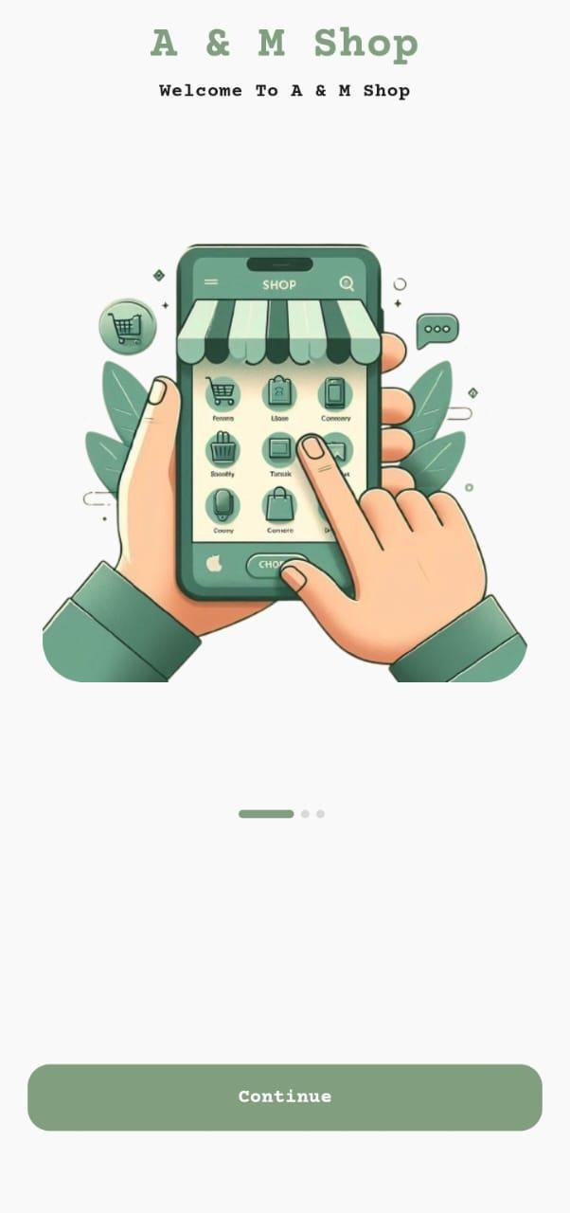 **On boarding screen 1**

**On boarding Screen 2**

**On boarding screen 3**

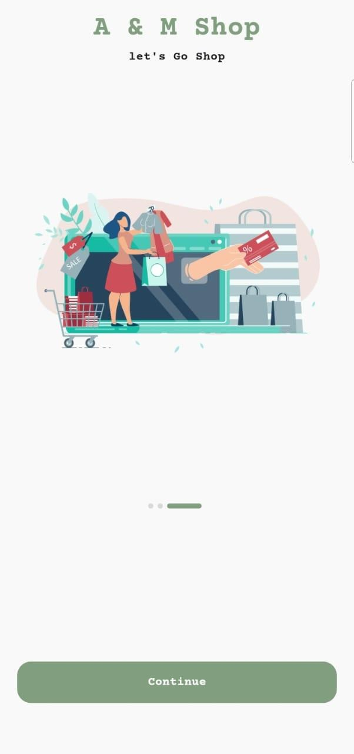

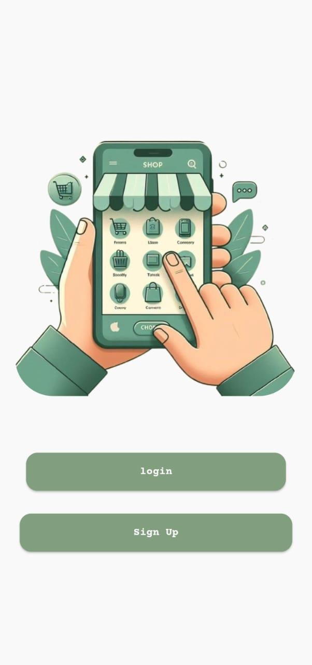

**Switch from login & signup** *screen*

**login *screen***



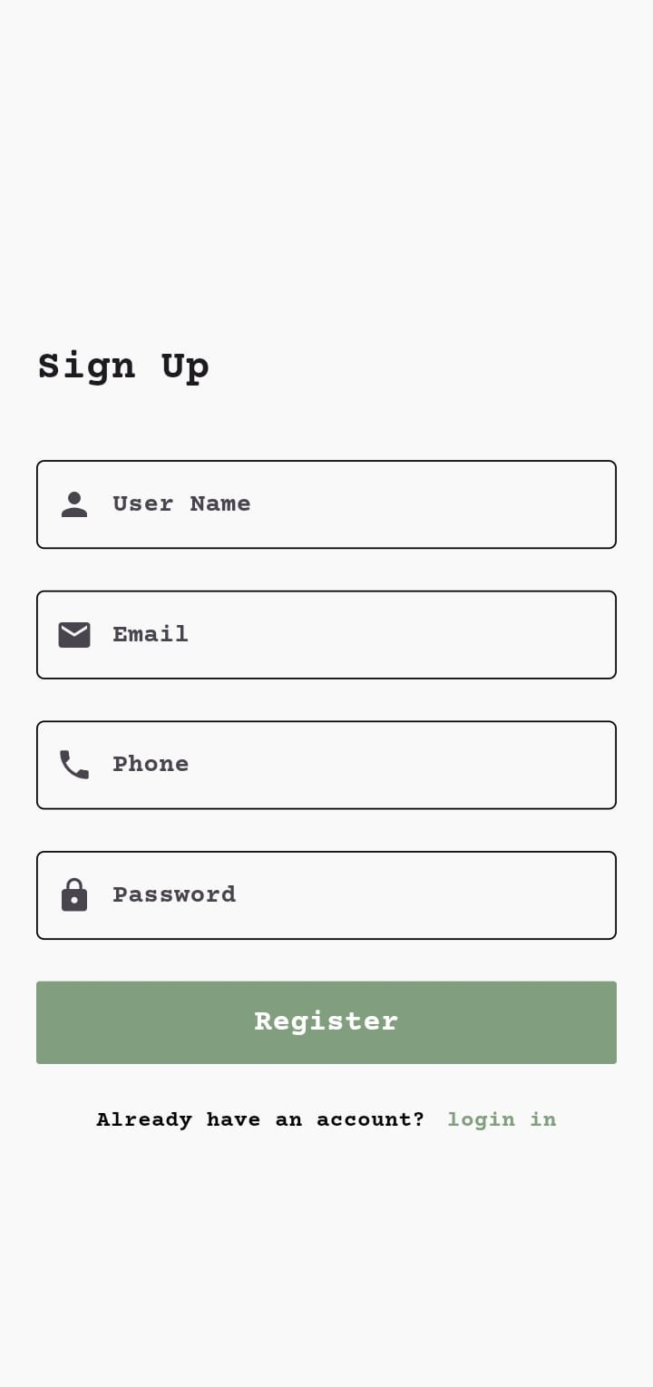

**Sign Up *screen***

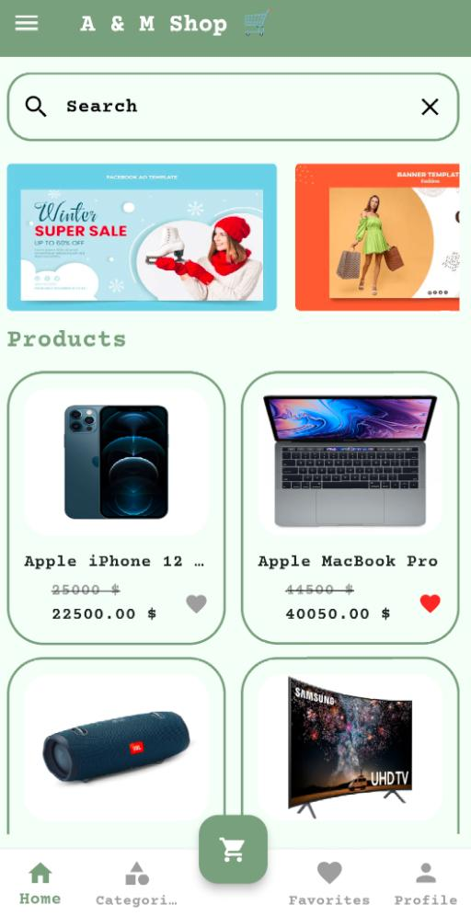

**Home *screen***

**Product *Screen***

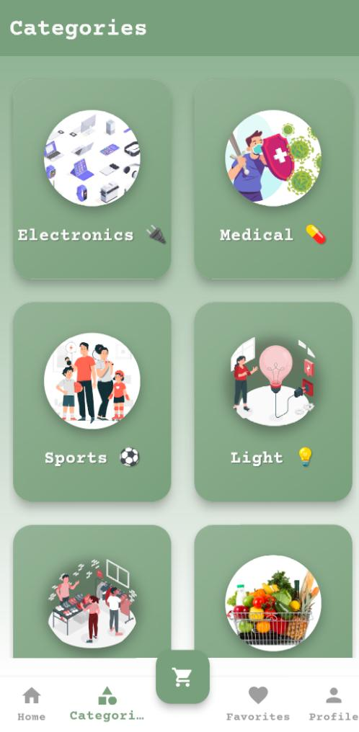

**Categories *screen***

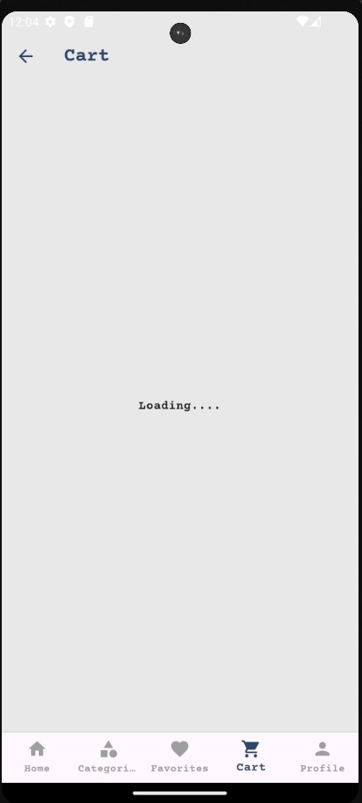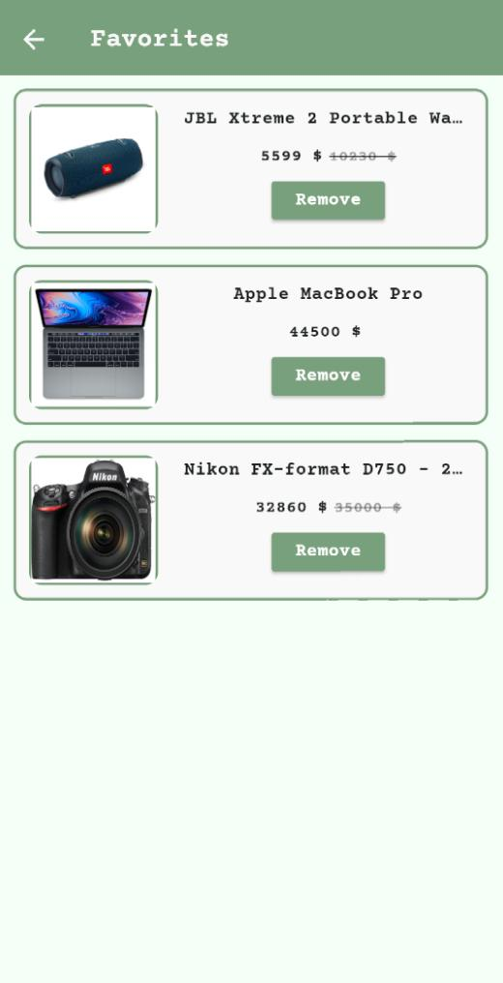

**Favorites *screen***

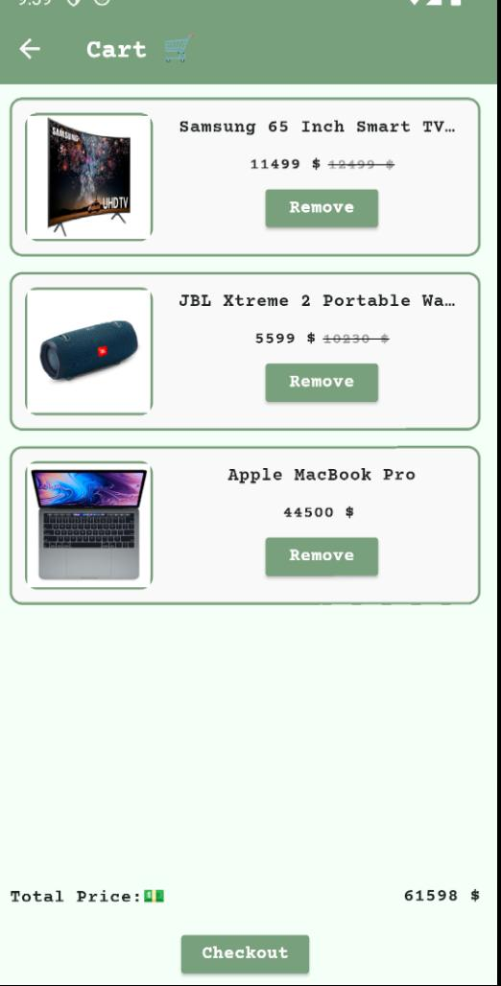

**Cart *screen***

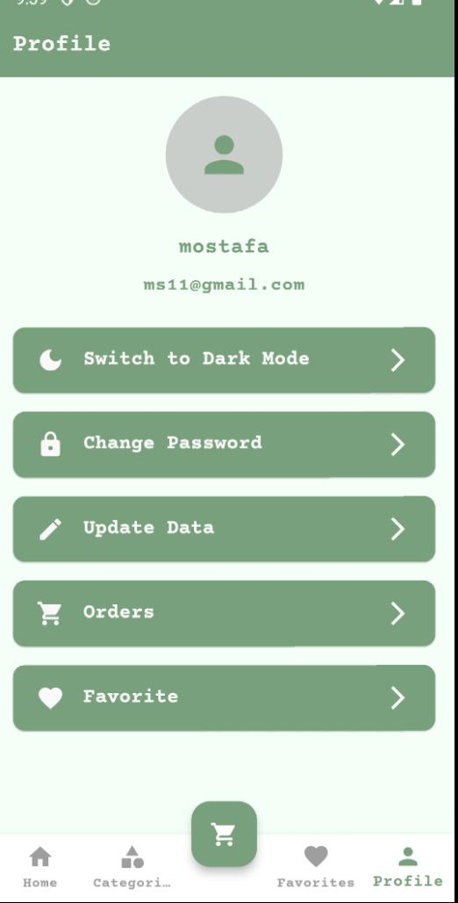

**Profile *screen***

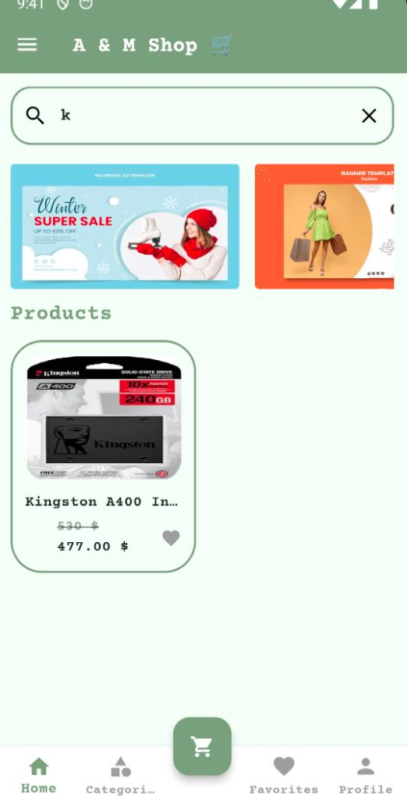

**Search *screen***

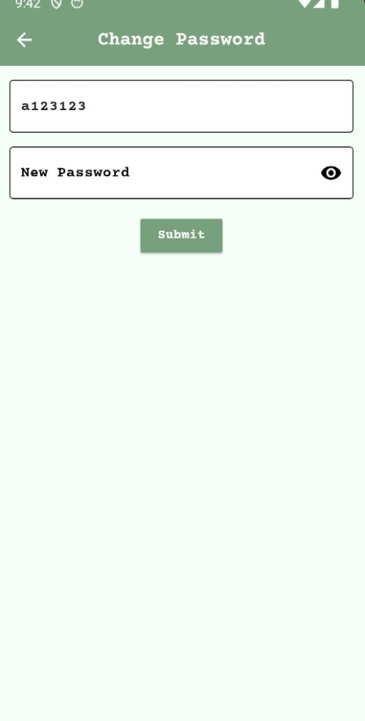

**Change Password *screen***

**Update Data *screen***

**Payment *screen***

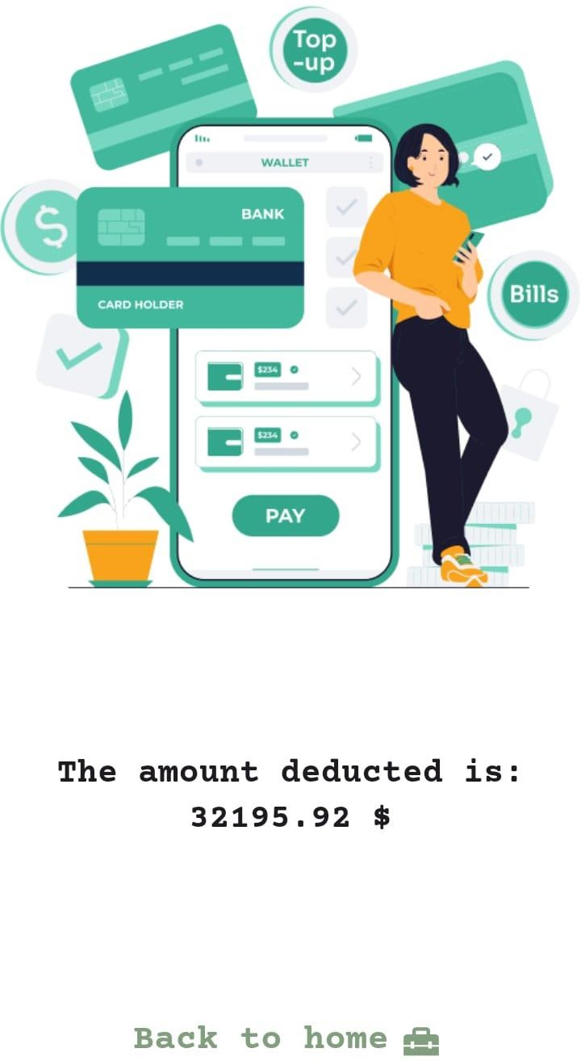

**Payment *screen***

**Payment *screen***

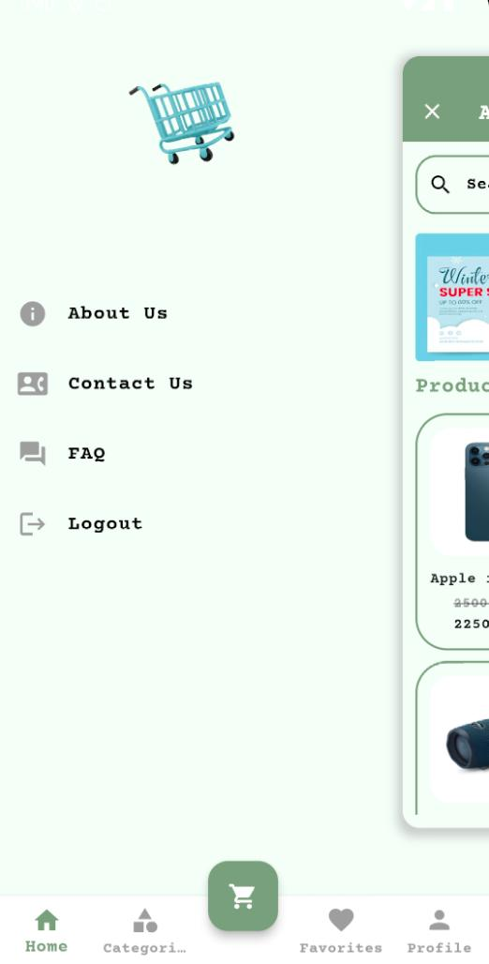

**Setting *screen***

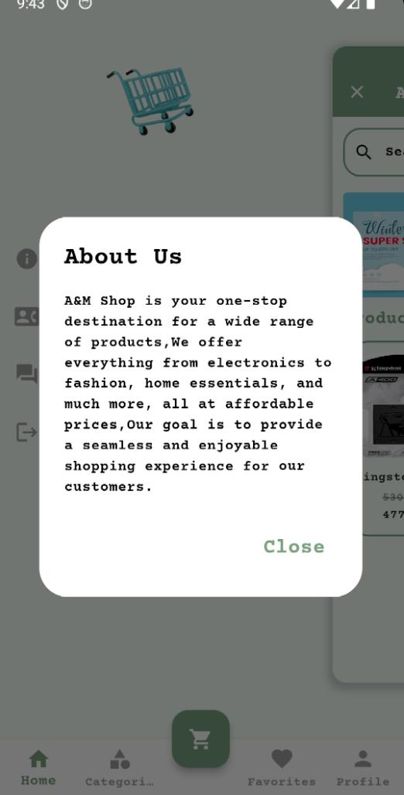

**About US *screen***

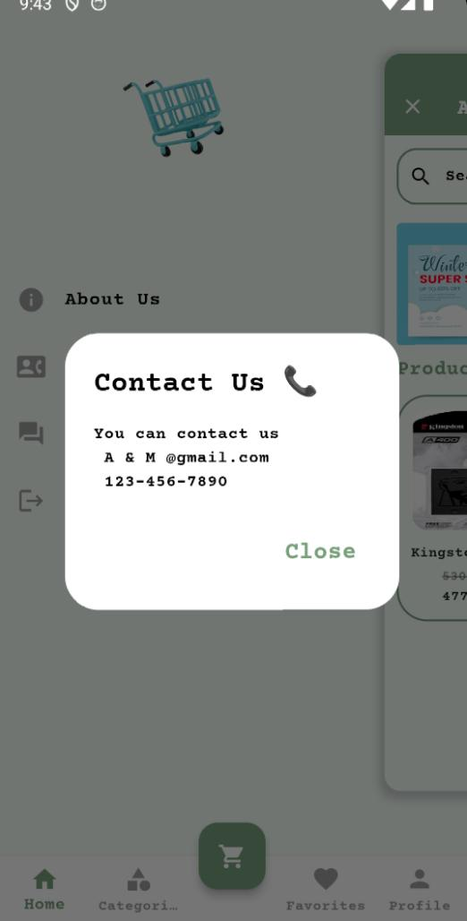

**Contact Us *screen***

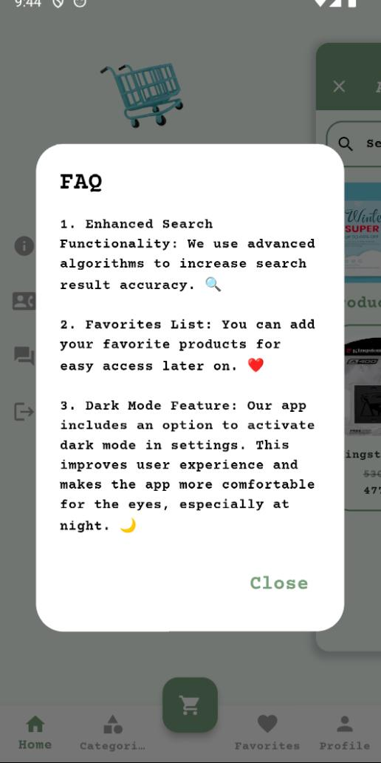

**FAQ *screen***

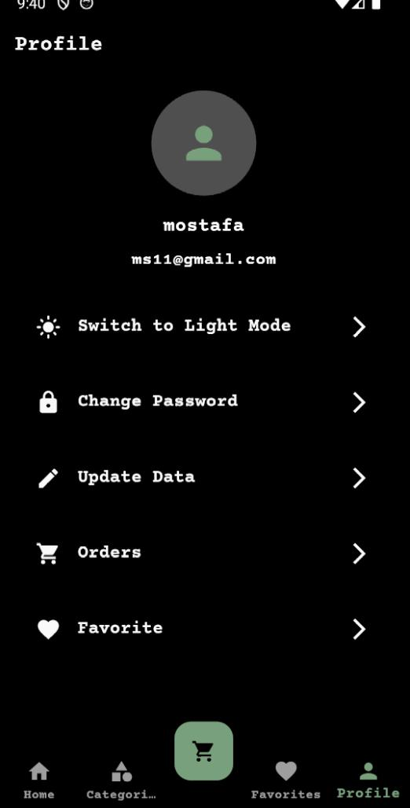

**Dark mode *screen***

**5.3 The backend:**

**we use Api for manages user data and product.  
link collection:** [**https://www.postman.com/collections/94db931dc503afd508a5**](https://www.postman.com/collections/94db931dc503afd508a5)

Chapter 6: Conclusion

The **A&M E-commerce Mobile App** successfully addresses the common challenges faced by users in online shopping, offering a user-friendly interface, fast product searches, and secure payments. It provides a smooth and reliable shopping experience.

Chapter 7: future scope

In the future, the app can be expanded to include features like AI-based product recommendations, voice search, and additional payment options such as PayPal and Apple Pay. Additionally, the system is scalable, allowing for more products and users as the app grow